Gamified Instructional Materials App
🎯 Project Objectives
- Develop a Native Mobile App: Create a downloadable mobile application (not a website) for gamified classroom instruction.
- Support High Concurrency: Ensure the app can smoothly handle 50+ students participating simultaneously in the same classroom without lag or server crashes.
- Secure Authentication: Implement email-based student login to automatically track identities and performance.
- Implement a Live Room-Code System: Allow students to instantly join a specific teacher's activity by typing in a unique session code.
- Provide Real-Time Leaderboards: Display dynamic, live-updating leaderboards during gameplay to boost student engagement.
- Enable Persistent Student Review: Automatically save completed games to the students' accounts as read-only history for self-assessment (preventing score manipulation).
- Create a Teacher Dashboard: Give teachers dedicated tools to organize activities by "Classes" or "Games" and instantly view, track, and export real-time student scores.
📑 The App Architecture & Data Flow
1.Entry (Authentication):
Phase 1. Students install the app and log in via Google Sign-In. Firebase Auth verifies identity and links them to their permanent StudentID.
2.Sync (Room Code Entry):
Phase 2. Students enter the teacher's code (e.g., ROBOT5). The app downloads the game questions and locks in the server deadline (server_end_time).
3. Core Loop (Dual-Write):
Phase 3. Students answer questions. Answers are written instantly to local device cache (via Hive) and simultaneously pushed to Cloud Firestore for live scoreboard updates.
4.Safety Net (Offline Fallback):
Phase 4. If Wi-Fi drops, the app switches to Offline Mode. The timer keeps ticking down against the fixed deadline. Answers are safely queued in the local phone cache.
5. Recovery (The 'Continue' Intercept):
Phase 5. If the phone reboots, the app bypasses the main menu and forces a [Continue Game] screen. It reads the local cache, restores the state, and uploads data when Wi-Fi returns.
6. Lockout (Read-Only Archive):
Phase 6. When the timer hits zero, input fields lock instantly. The score packet is finalized and changed to read-only accessible for student review, but uneditable.
📡 Data Communications and Networking Configuration
📊 Summary Comparison
Feature | Online Cloud (Wi-Fi + Internet) | Offline LAN (Local Wi-Fi Router) | Offline Bluetooth
Supports 50+ Users? | Yes (If internet is stable) | Yes (Highly stable & fast) | ❌ No (Max 7-8 users)
Leaderboard Speed | Moderate (Depends on internet) | ⚡ Extremely Fast (Zero internet lag) | ❌ Broken / Laggy
Review at Home? | Yes (Data is in the cloud) | ❌ No (Only works in class) | ❌ No
Setup Difficulty | Easy (Standard Firebase setup) | Medium (Requires a local database server) | Extremely Hard
👣 Roadmap
🛠️ Step 1: Get Your Tools Ready
- [ ] Install Flutter: Download Flutter onto your computer. This is the software you use to write the app.
- [ ] Set up Firebase: Go to Google's Firebase website and create a free account. This will be your internet database where scores are saved.
- [ ] Turn on Google Login: Inside Firebase, flip the switch to allow students to log in using their Gmail accounts.

🖥️ Step 2: Build the Inside of the App
- [ ] Make the Login Screen: Create a simple page with a "Log in with Google" button.
- [ ] Make the Code Page: Create a box where students type the teacher's game code (like ROBOT5) to join.
- [ ] Build the Timer: Set the clock to follow internet time, so students cannot cheat by changing their phone’s clock settings.
- [ ] Create the "Double-Save" Feature: Program the game buttons to save answers to the phone's memory first, and then immediately send them to the internet.

🛡️ Step 3: Add the Safety Net (For Wi-Fi Drops)
- [ ] Build the "Continue" Button: Program the app so if a phone dies or crashes, opening it again immediately shows a big [Continue Game] button.
- [ ] Create the Auto-Sync: Write a hidden rule that says: "The moment the Wi-Fi turns back on, automatically send all saved answers from the phone to the teacher."
- [ ] Make the Teacher's Screen: Build a simple dashboard where the teacher can watch a live list of student names and scores moving up and down.

🧪 Step 4: Test and Run It
- [ ] Test with Friends: Have 5 to 10 friends join at the same time to see if the leaderboard works without lagging.
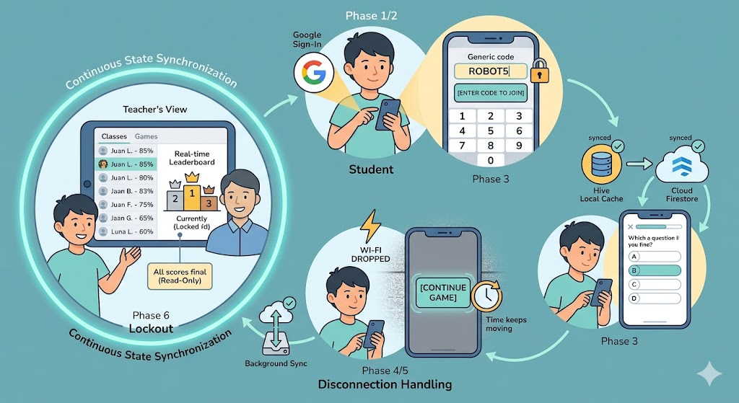
- [ ] Create the Download File: Click "Build" in Flutter to create an .apk file. This is the file you send to your 50 students so they can install it on their phones!
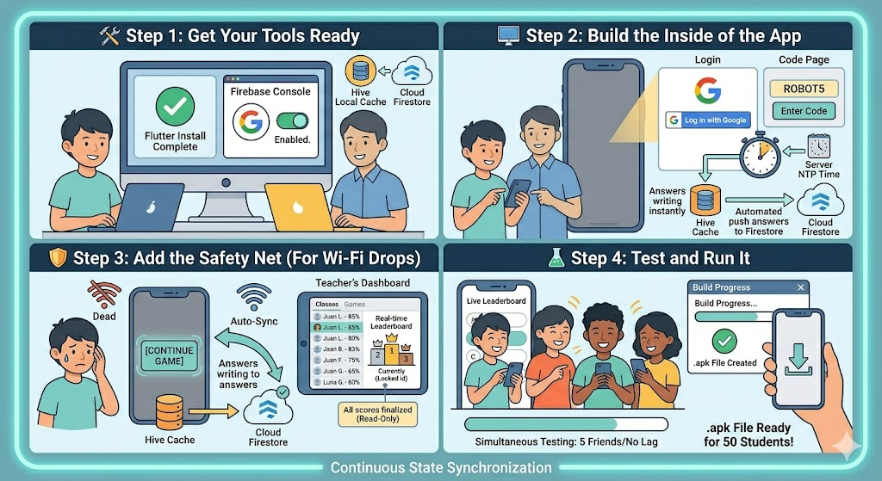
Figure 1: The Entire Ecosystem of the App
Figure 2: Development Journey

